Computing Research Methodologies Project Proposal: Gym Whim

Contents

Aims of Gym Whim 1

# Aims of Gym Whim

Throughout the years, I have been a regular user of the gym, which means in the beginning, I didn’t know where to even start from. I jumped from website to website, blog to blog, app to app, more than 10-15 fitness apps I downloaded in search of answers for questions I had. I also searched for gym techniques, positions, and much more. This being said, one of my aims for this app is to provide something that through my experience, many of the apps, if not all of them, failed to provide me as a gym user in its Beginning and Intermediate state.

Some of the concerns which I have found as a user of each one of these apps are the following (worth noting that I will implement the solution on my app for each of the concerns I list):

* Too technical description of each exercise.
* Very basic stick-man-like pictures of the initial and end form, but no actual picture of the process in the middle of the act form.
* Ugly UI for the app.
* Lack of structure and organisation.
* Each exercise should be grouped in “Muscle groups”.

Some interesting ideas I had to implement in this application would be to develop a detailed 3D model mannequin, which would be doing exercise, in an infinite loop. Whilst the mannequin performs the exercise, the user is allowed to rotate it in a 365° so that he gets the full “picture” of every single point and technique that it takes to perform the exercise correctly, in terms of posture, hand grip, hand positions, etc.

# Literature Review

One of the problems that I underlined above, was that some apps are too technical when it comes to describing each exercise, and they possess too much data. (MAJOCHA, n.d)  
The following image is an example of this:

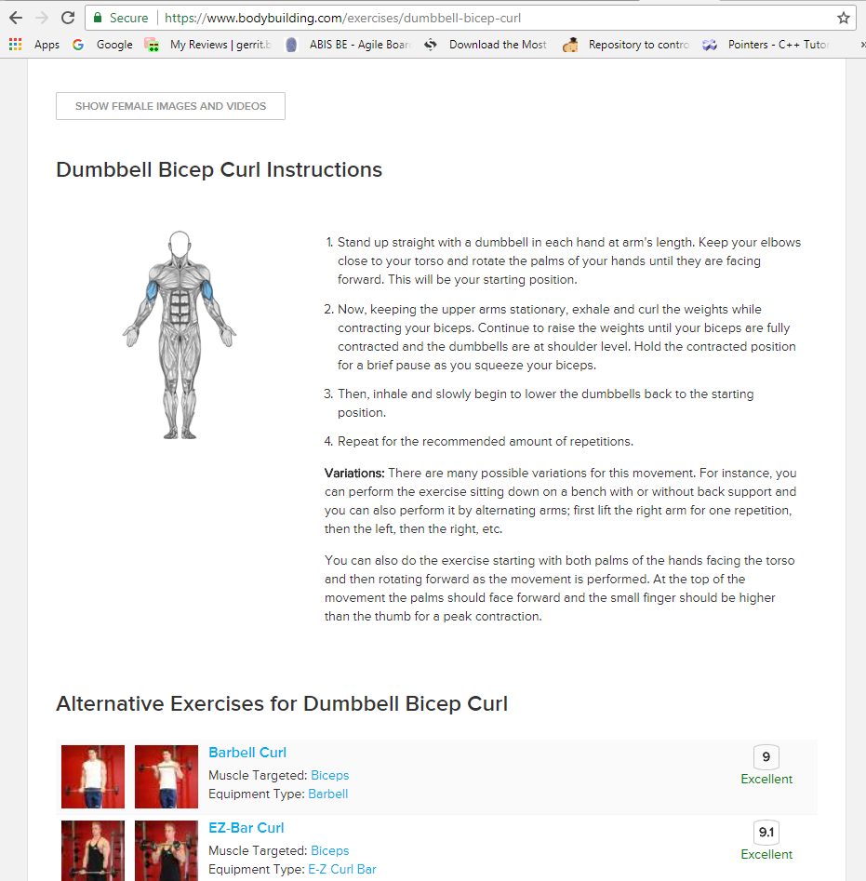

Image 1 of [www.bodybuilding.com](http://www.bodybuilding.com)

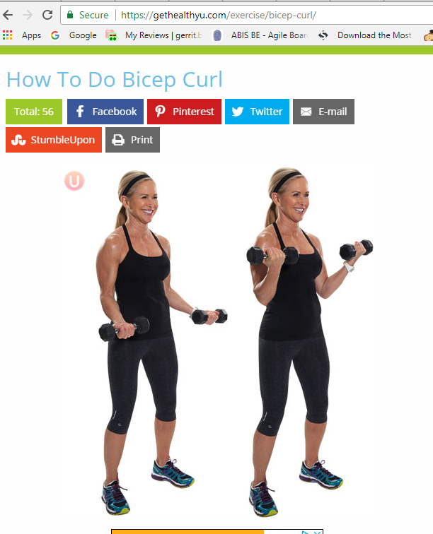

Image 2 of [www.gethealtyu.com](http://www.gethealtyu.com)

Nothing in this images (Image 1 and 2) presents the solution which I have underlined above, when it comes to showing pictures or information of the “mid” form. (Bodybuilding, n.d)

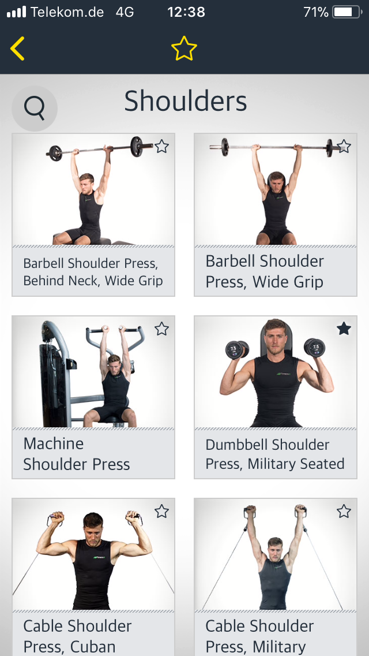

Image 3 picture of app “Workout” on iOS

Image 3 is a screenshot of the app “Workout”, which shows the menu for Shoulder exercises. It cannot be seen on this picture, but this menu has over 100 exercises just for the shoulder, which makes it overwhelming for the user to decide which exercise to do. This would impact beginners/intermediate lifters.

# Plans

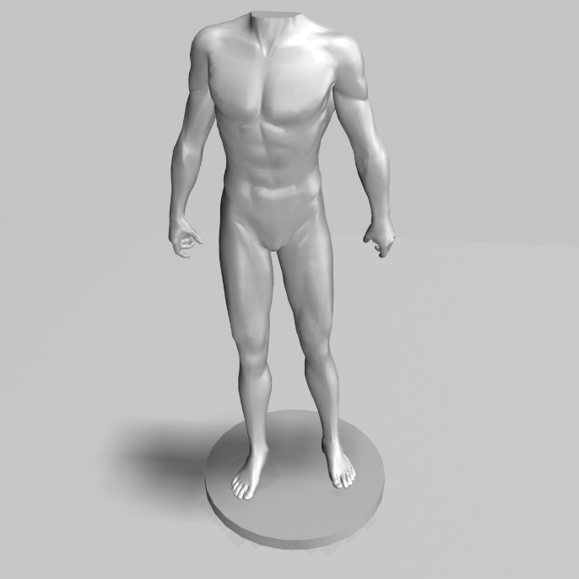First, I intend to make an UI, that has is aesthetically beautiful and appealing to the eye. The next step would be to make the UI user friendly and very easy to use, with all the other things that I have learned by looking at other gym apps, I have gathered what kind of app I want it to be.   
The plan is to make an app that is focused on one thing only, which every single person struggles in most apps. I want to make an app that focuses on showing the user, how to do a certain exercise with the correct form through an interactive 3D mannequin, where you can rotate it to any 360 degrees position. This would allow the user to see every point of a certain exercise in a certain perspective, that perhaps they might not be doing it correctly.

The image on the right shows the kind of 3D mannequin I would be looking at. I would give it human skin colour everywhere, and then whatever type of exercise it is, so for example if the exercise is a chest workout, the chest area would be covered in red.

Moreover

# References

Bodybuilding, n.d. *Dumbbell Bicep Curl.* [Online]   
Available at: https://www.bodybuilding.com/exercises/dumbbell-bicep-curl  
[Accessed 09 05 2018].

MAJOCHA, I., n.d. *7 THINGS PEOPLE HATE IN FITNESS APPS.* [Online]   
Available at: https://www.ready4s.com/blog/7-things-people-hate-in-fitness-apps/  
[Accessed 09 05 2018].